



Performance Evaluation 59 (2005) 121–136

Internet like control for MPLS based trafﬁc engineering:
performance evaluation
A. Boscoª, A. Botta^{b}, G. Conte^{b}, P. Iovannaª, R. Sabellaª, S. Salsano^{c},∗
a Ericsson Lab Italy, Research and Innovation Unit, Via Anagnina 203, 00040 Rome, Italy
b CoRiTel—Consorzio di Ricerca sulle Telecomunicazioni, Via Anagnina 203, 00040 Rome, Italy
c DIE—Universit`a di Roma “Tor Vergata”, Via del Politecnico 1, 00133 Rome, Italy
Available online 11 September 2004

Abstract

This paper reports a realization of a trafﬁc engineering (TE) strategy based on a distributed control plane (Internet-
like), and a performance analysis based on experiments carried out on the realized test bed and on simulations. The
implementation of control plane is based on standard IP protocols, namely OSPF-TE for routing and RSVP-TE
for signaling, which have been suitably extended to support the reported TE strategy. Furthermore, a threshold
mechanism for limiting the information ﬂood in the network is reported. The performance analysis assesses the
validity of the proposed strategy, by reporting simulation results and measurements achieved on the test bed. In
particular, the paper shows that the non-ideality due to real signaling ﬂow and related databases updating are
reasonable and in-line with real systems.
© 2004 Elsevier B.V. All rights reserved.

Keywords: MPLS, GMPLS, Trafﬁc engineering

1. Introduction

A very challenging task for new generation networks (NGN) concerns the deﬁnition of a control plane
able to combine the simplicity of use and automation of procedures, proper of the Internet world, with
the reliability and high performance provided by traditional Telecom management. Multi protocol label
switching (MPLS) and its extension, generalized MPLS (GMPLS), are suitable technologies to satisfy
such requirements because allow applying efﬁcient Trafﬁc Engineering functionality in IP contest. In

∗ Corresponding author. Tel.: +39 06 72597450; fax: +39 06 72597435.
E-mail address: stefano.salsano@uniroma2.it (S. Salsano).

0166-5316/$ – see front matter © 2004 Elsevier B.V. All rights reserved.
doi:10.1016/j.peva.2004.07.010

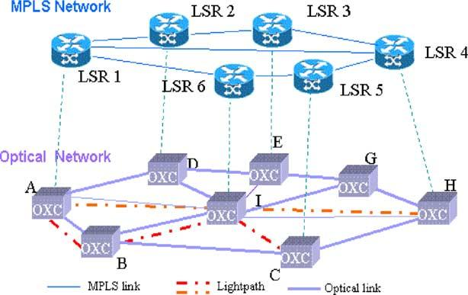

122

A. Bosco et al. / Performance Evaluation 59 (2005) 121–136

principle, thanks to the extension of IP based routing and signaling protocols, the control plane should
be able to perform network operations automatically, providing a level of quality of service (QoS) that is
comparable to that one granted by connection oriented technology (e.g. ATM and SDH).
A lot of relevance is given within standardization bodies to deﬁne protocols, strategies, mapping criteria
among different technologies to deﬁne all the ingredients necessary for applying trafﬁc engineering based
on the (G)MPLS paradigm in NGN, but a feasible solution that is able to use such ingredients is still not
consolidated.
Particularly, the analysis of which TE functions can be implemented in a distributed way, supporting
QoS, without affecting both performance and scalability of the solution is a key issue to be addressed.
The scope of this work is evaluating the performance of a TE strategies bases on a simulation tool
where the impact of signaling is not considered and a test bed where a distributed implementation of such
TE strategy is performed, making use of real signaling (RSVP-TE) and routing (OSPF-TE) protocols.
Speciﬁcally control plane architecture for the distributed implementation is presented and analyzed.
The performances of such implementation will be evaluated in terms of QoS capability support and
scalability issues.
Moreover, the description of main test beds and relating TE architecture reported in literature are also
presented and compared with the proposal implementation, in order to give a reference context of the
main issues that are considered in this ﬁeld.

2. TE strategy

In this work, the performance of the TE solution reported in [1] for a MPLS/GMPLS based scenario
is analyzed. The reference scenario is based on a multi-layer network composed by MPLS router (LSR)
and optical nodes (see Fig. 1). The end-to-end path in the MPLS layer is named label switched path
(LSP), while it is named lightpath in the optical layer. The considered TE solution is based on a hybrid
routing approach and a bandwidth engineering mechanism [2] in order to optimize the use of resources
and guarantee tight QoS support.
Speciﬁcally, the hybrid routing allows calculating the routes for LSP requests using a combination
of off-line and on-line methods. The off-line technique allows performing a global optimization of the

Fig. 1. Reference scenario.

A. Bosco et al. / Performance Evaluation 59 (2005) 121–136

123

network resources on the multi-layer network. This method is based on the a priori knowledge of the
trafﬁc amount that the network has to handle [3]. The on-line approach, on the other hand, allows
accommodating each single trafﬁc request that was not predicted, taking into account the actual state of
network occupancy, by means of constraint based routing (CBR) described in [4]. Two main classes of
trafﬁc are considered: the high priority trafﬁc class (HP) and low priority one (LP). HP class represents
the portion of trafﬁc that has to be guarantee whatever is the network load. This means that, at any time
and for any trafﬁc distribution in the network, HP trafﬁc must have an amount of available bandwidth up
to a maximum value (MV) agreed by service level agreement (SLA).
LP class represents the trafﬁc that is not guaranteed and/or it is not foreseen, thus it can be re-routed,
not accommodated or torn down, in case of network congestion.
In each LSP just one type of trafﬁc can be mapped (L-LSP [5]), so, in this work, HP-LSP and LP-LSP
are considered. In order to better use the network resources, the bandwidth engineering mechanism is
used [2]. This mechanism is based on a pre-emption algorithm and re-routing function as it is explained in
the following. Practically, the bandwidth not used by HP-LSP is temporarily released to accommodate LP
trafﬁc, due to the use of “modify” function [5]; but, if needed, HP-LSP can require to increase/decrease
the amount of bandwidth up to MV, dynamically. In case of bandwidth increasing request, some LP-LSPs
could be pre-empted for satisfying the HP request. In order to reduce the loss of LP trafﬁc, the pre-empted
LP-LSPs are re-routed in less congested paths.
In the considered TE solution, the multi-layer global optimization is performed by means of a provi-
sioning tool (named PR module), as described in [3].
This module takes as input: (i) the physical topology of the network; (ii) the HP trafﬁc matrix, where
the maximum value agreed by SLA is considered; and (iii) an LP expected trafﬁc matrix, whose elements
are determined through statistical evaluations. The output of the provisioning module consists of (i) the
set of lightpaths (i.e. the optical LSPs according to GMPLS LSP hierarchy) that represents the logical
topology of the optical layer, and (ii) the routes for all the LSPs groomed into the lightpaths. Particularly,
the routes for HP-LSP are stored in a database named ﬁxed route (FR). The on line route calculation for
LP trafﬁc set up/re-routing is performed by means of a dynamic routing algorithm described in [4]. As
consequence, both HP and LP trafﬁc are served on demand, but HP trafﬁc routes, off-line calculated, are
ﬁxed, while LP trafﬁc routes can be dynamically changed according to the actual network status.
For sake of simplicity, it has been assumed that the dynamic routing module cannot set up new lightpaths
during the on-line operations, but it can only operate on the logical topology derived during the off-line
provisioning phase. As a result, the establishment of one or more lightpaths can only follow the decision
of off-line providing a greater logical capacity to the network due to special events (e.g. when a new
Internet service providers enters the network).
This module operates on-line accommodating an LSP at time on the bases of the current status of the
network learnt by routing protocol.
The dynamic routing algorithm aims at better utilizing network resources, by using less congested
paths instead of shortest, but heavily loaded paths as described in [4], and evenly distributing the trafﬁc
at MPLS layer on the logical topology. The bandwidth engineering mechanisms allows handling the
connection in ﬂexible way and preventing the congestion when the combination of the hybrid routing is
not sufﬁcient. As a result the system allows accommodating also the trafﬁc that was not foreseen during
the off-line phase, guaranteeing the QoS for HP trafﬁc. Detailed analysis of the performance of each
algorithm that has been used of for each module has been performed in [2–4].

124

A. Bosco et al. / Performance Evaluation 59 (2005) 121–136

3. Control plane architecture

The TE strategy described in Section 2 can be implemented in different ways: centralized, distributed
or hybrid manner. It could be useful to distinguish among TE operations that can be performed “off-line”,
such as HP route calculation, and global path optimization; and TE operations that are performed on-
line, like LP route calculation for LSP set-up/re-routing, pre-emption, and HP modify. The former type
of operations can easily be achieved in both distributed and centralized manner, since the information
needed to perform such operations can be made available without strict requirements on the signaling,
and the level of updating of the databases where the information on the status of the network are stored,
is not an key constraint.
More relevant is the application of the “on-line” TE operations: i.e. the CBR and the pre-emption. The
efﬁciency of these functions depends on the updating level of the information stored in the databases
described in Section 2. The control plane architecture that has been considered for performing dynamic
TE operations using OSPF-TE and RSVP-TE is described in [16]. A challenging target is analyzing
the performance of these operations in case of a distributed implementation. The efﬁciency of routing
decisions could suffer from inconsistent co-ordination between the various network elements when the
implementation is distributed, due to the time necessary to propagate the information and the imprecision
of the information. On the other hand, as it is well known [6], the feasibility of a distributed implementation
requires to reduce the amount of signaling that is ﬂooded in the network and meet stability requirements, by
means of the use of mechanisms that reduce the level of updating of the information about the network state.
In order to evaluate such features, distributed control plane architecture and its implementation by
means of a test bed are considered. Moreover, a comparison with the performance analysis of the TE
solution obtained in an ideal environment, without considering real protocols for routing and reservation,
is also performed in order to evaluate the performance of the TE solution in two different environments.

4. Testbed implementation

Speaking about trafﬁc engineering realized by means of MPLS functionalities, all the protocol aspects
strictly related with the performance obtainable, are the main topics to be analyzed.
As a consequence, it is easy to understand that a prototype implementation of the whole strategy is
essential to carry out not only a simulative analysis of different strategies comparison, but also to study
consistency aspects, in terms of existing protocols standardization and different protocols interoperability.
The need of an implementation of an MPLS-TE network control plane in a real test bed is even more
important because all trafﬁc engineering functionalities are realized by means of protocol extensions and
an effective interoperability of each single functional block realizing the node’s architecture. Moreover,
remarking that all the TE functionalities have to be carried out dynamically in each LSR (distributed
architecture), it is clear how important is the possibility to measure the performance reached in terms of
rapidity and scalability of all the operations realized by each node.

4.1. Related works

Several TE implementations have been already proposed in literature. Most of them relate with the
management plane of MPLS networks. In this sense, a lot of management servers have been developed to

A. Bosco et al. / Performance Evaluation 59 (2005) 121–136

125

monitor network element and trafﬁc performance. In this scenario the RATES server [11] is an important
work to remind to. It is a software system developed at Bell Laboratories. It is completely based on
centralized paradigm: RATES server communicates with the nodes of the MPLS networks and spawns
off signalling from the source to the destination for route LSPs set-up. This kind of communication is
viewed as a policy decision and therefore Common Open Policy Service (COPS) protocol is used for this
scope. In RATES scenario all trafﬁc engineering aspects are simply treated as routing decision taken by
the central server, leading to a leak of dynamicity of the solution proposed.
Another state dependent TE mechanism to distribute network load adaptively is suggested in [12].
MATE assumes that several LSPs have been established between a couple of node in an MPLS domain
using a signalling protocol as RSVP-TE. In this way, the ingress node has simply to distribute incoming
trafﬁc across the LSPs. It is important to note that MATE is thought for trafﬁc without bandwidth
reservation. So, the ingress node has to measure the available bandwidth in term of packet delay and
loss and these measurements operations, repeated in each ingress node of the network, could easily
lead to loss of dynamicity and scalability. All these problems could be overcome by the introduction of
bandwidth reservation and the presence of a link state routing protocol extended with TE capabilities.
TEQUILA [13] is a European collaborative research project looking at an integrated architecture
and associated techniques for providing end-to-end QoS in a DiffServ-based Internet. In TEQUILA, an
integrated management and control architecture has been designed. The TEQUILA architecture includes
control, data and management planes. The management plane aspects are related to the concept of a
centralized bandwidth broker (BB). The BB includes components for monitoring, TE, SLS management
and policy management. The dynamic route management module considers: (a) setting up the forwarding
parameters at the ingress node so that the incoming trafﬁc is routed to LSPs according to the bandwidth
determined by network dimensioning, (b) modifying the routing according to feedback received from
network monitoring and (c) issuing alarm to network dimensioning in case available capacity cannot be
found to accommodate new connection requests.
The control plane aspects are related totally to RSVP signalling protocol and its extensions to support
trafﬁc engineering. In this sense, the work carried out in the framework of TEQUILA project is very
important, and, among relevant results, it worth to remind the development of an open source version
of RSVP-TE protocol. This version of the signalling protocol is equipped with the capability to dynam-
ically setup explicitly routed LSPs with quality of service requirements (only L-LSPs were supported)
and represented an important starting point to develop our current version of RSVP-TE used in our
implementation.
Another relevant implementation of a trafﬁc engineered MPLS network is represented by the TEAM
proposal [14]. TEAM is a trafﬁc engineering automated manager, realized in a central server interacting
with the elements of the MPLS network. Various measurements are retrieved from network nodes (queue
lengths, available bandwidth, overall delay, jitter, number of packet dropped, etc.) and the network man-
ager takes TE decisions in a completely off-line fashion. All the interfaces to the routers are based on
SNMP, COPS and CLI commands. This means that TEAM is related only on management plane aspects
and an accurate control plane performance study is still missing.
As a matter of fact, it is evident that low attention has been given to realizing and analysing distributed
implementation of the MPLS network’s control plane. Moreover, even if several TE strategy have been al-
ready proposed, our hybrid approach, resulting in a combination of off-line and on-line TE functionalities,
is totally new and unexplored.

126

4.2. Building blocks

A. Bosco et al. / Performance Evaluation 59 (2005) 121–136

MPLS-TE prototype implementation has been realized by means of general purpose PCs with a Linux
Operating System. The reason for choosing this platform is mainly due to the huge availability of open
source software and by the possibility to modify and extend existing protocols. The PCs (Pentium III 350
and 600 MHz) are interconnected by means of fast Ethernet point-to-point links.
The starting point for our work was a set of open source software packages:
- MPLS provided by Sourceforge [15];
- RSVP-TE daemon from TEQUILA project [8];
- OSPF-TE daemon by Zebra [7].
With all these pieces running in a stand-alone fashion, there is no integration among all the elements.
RSVP-TE and OSPF-TE, for example, run separately, without the possibility to communicate one another.
Moreover, there is no “intelligent” functional element like a Route Decision Engine to trigger LSPs set
up and tear down.
In order to support the functional architecture described in the previous sections, with all foreseen
capabilities, it is necessary to adapt each of the mentioned package to meet the desired behaviour. In this
sense, RSVP-TE protocol was extended to support LSP bandwidth modify request, according to the [9].
In addiction, the capability to manage with different classes of trafﬁc was introduced in the RSVP-TE
implementation, making it DiffServ aware capable.
Also OSPF-TE protocol implementation was enhanced with an ad hoc mapping of RSVP classes in
different Class Types and with the possibility to ﬂood in single Opaque-LSA bandwidth information for
all the Class Types. This will lead to a relevant decrement of OSPF message ﬂooding in the network.
In order to further reduce the amount of signalling in the network, a threshold system is also im-
plemented. In particular, such a method reduces the number of OSPF advertisements because a single
advertisement is performed after more LSP set ups instead of after each LSP set up.
Several performance study comparisons among different threshold methods are present in literature
and a detailed analysis leads to the choice of a “dynamic threshold” mechanism. Such a method considers
an initial threshold level on the empty link. The next upper and lower levels are calculated dynamically
taking into account the amount of the currently advertised reserved bandwidth (B) and the link capacity
(C) according to the following formula:

B+ = B + F (C − B),
B− = B − F (C − B)

where B+ is the upper level, B− is the lower level, and 0 ≤ F < 1 is a parameter that regulates the
granularity level of the thresholds. The greater F value is the coarser the information ﬂooded by the
protocol will be. So, as emphasized in Section 6, OSPF ﬂooding will decrease with higher value of F,
with the trade off of not degrade network performances.
To complete the node architecture a “Node Decision Engine” module was implemented. It processes
each trafﬁc request incoming to the node, calculate, when needed a constrained shortest path for LSP
routing, with the possibility to run different routing algorithms. Furthermore, the Node Decision Engine
collects every statistics in terms of request satisfactory and time response of the whole system. In this way
it is possible to analyze architectural performances, measuring both the amount of trafﬁc accommodated
in the network and the time latency aspects strictly related to protocol behaviour. In Fig. 2 the ﬁnal node
architecture is represented.

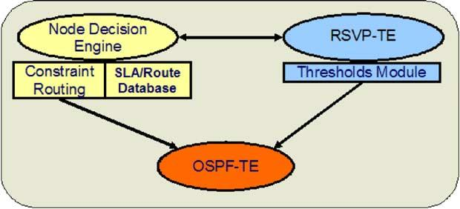
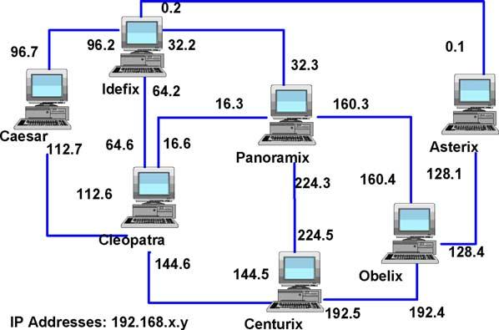

A. Bosco et al. / Performance Evaluation 59 (2005) 121–136

Fig. 2. Node architecture.

4.3. TE-functionalities implementation

127

The testbed is composed of seven PCs, interconnected according to the topology shown in Fig. 3. The
trafﬁc engineered network has been emulated with two classes of trafﬁc, realizing a static mapping of
trafﬁc classes (PSCs) into two CTs. Each node is conﬁgured with a maximum bandwidth available for
each trafﬁc class.
The OSPF-TE distributes the topology and the information of resource utilization per trafﬁc class.
It is able to send the unreserved bandwidth values for every CTs in a single opaque LSA, as said in
precedence. At the beginning all resources are available. Following the LSP setup procedures, achieved
with RSVP-TE signalling, resources are removed along the paths taken by the LSPs. The new bandwidth
availability values are communicated through OSPF ﬂooding, with the described mechanisms to control
the amount of the exchanged information. In this way, each LER is able to select a constraint based
route for every LSP request it receives, with a good approximation of resources occupation in the whole
network at the moment the request is received.
For sake of generality, each node can act as an edge node: it can be either source or destination of a
given path. When it acts as source, it reads the route of HP-LSPs from the FR, which has been populated
according to the provisioning module procedures [3], or calculates the route of LP-LSPs using the dynamic
routing algorithm [4].

Fig. 3. Testbed topology.

128

A. Bosco et al. / Performance Evaluation 59 (2005) 121–136

The resource reservation is performed by means of RSVP-TE, using the admission control function
that is performed node by node according to the version described in [9].
The architecture emulated in the test bed in its entireness offers the possibility to perform a complete
comparison study among different strategies or different algorithms evaluating all the aspects related to
the control plane performances.
The evaluation criteria considered here for TE strategy performance are: (i) the amount of trafﬁc ac-
commodated with TE with respect to the one in a traditional over provisioning; (ii) the QoS provided to HP
and LP trafﬁc; and (iii) the scalability of the solution that is implemented in distributed way and makes use
of routing and signalling protocols to automate network operations. The accommodation of more trafﬁc is
realized by means of the bandwidth engineering system [2], which allows an elastic use of the bandwidth
of each link. In this way, each request uses just the amount of bandwidth that it needs for the desired amount
of time, putting at disposal the unused portion of bandwidth resource when this is not utilized ad the advan-
tage of the lower priority trafﬁc requests. As a result an efﬁcient use of the network resources is obtained.
As far as the QoS the following considerations apply. The TE assures QoS to HP paths by dimensioning
their routes at the MV during the off-line optimization, by using bandwidth engineering to prevent possible
congestions along the HP routes, and guarantees the agreed bandwidth for HP-LSP whatever is the trafﬁc
load in the network. Even if the bandwidth temporarily not used by HP is put at disposal to LP-LSPs,
TE strategy has to operate in way that HP-LSP ignores this fact. In other words the HP-LSP bandwidth-
increasing request must be always fulﬁlled without delay even if some LP-LSPs occupy a portion of its
bandwidth. It is worth to remind that modify is performed by means of RSVP-TE. Speciﬁcally, a local
admission control is performed in order to vary the bandwidth attribute of an already set up HP-LSP.
Thus, bandwidth engineering (BE) operations have been implemented as explained in the following.
Node by node the admission control veriﬁes the availability of bandwidth. In case of lack of resources,
the admission control is stopped, the BE algorithm, that is implemented within the admission control
function, selects the LP-LSPs to be pre-empted that are pre-empted at once, then the admission control
success and the modify operation proceeds on the entire HP path. As far as LP-LSPs is concerned,
the TE strategy aims at providing QoS also for LP trafﬁc that is superior to “best effort” performance.
Speciﬁcally, the selection criterion, described in [2], aims at minimizing the number of LP-LSPs that are
pre-empted. In fact, LSPs presented in the link are sorted according their bandwidth attribute, and the
minimum number of LSPs that can satisfy the request is chosen. Taking into account that the control is
distributed, the selection criterion can utilize just the local information at disposal of that node relating
to the LSPs that it handles.
After having selected through BE the LP-LSPs that will be preempted, the node notiﬁes this event to
the source node of that LP-LSP, so the source node can promptly operate the re-routing of that LP-LSP.
In order to minimize re-routing time, the pre-emption notify uses RSVP-TE [9]. Speciﬁcally, for
each pre-empted LP-LSP, the node where the pre-emption has been performed sends two messages
concurrently. The ﬁrst one (“PATH ERROR” with a code that indicates pre-emption event) is sent upstream
towards the source node that provides to make free the resources up to the congested link by means of a
PATH TEAR message; the second one (“PATH TEAR”) is sent towards the destination node in order to
releasing the resources from the node where the pre-emption has been carried out to the destination node
at once. Then the source node provides to re-route the pre-empted LP-LSP if it is possible, otherwise that
LP-LSP is not accommodated.
In summary, the strategy minimizes the number of LP-LSPs that have to be re-routed, reduce the
number of LP-LSPs torn down after the pre-emption owing to network congestion, and minimize the

A. Bosco et al. / Performance Evaluation 59 (2005) 121–136

129

time to perform re-routing. The fulﬁlment of such requirements allows superior QoS be obtained for
LP-LSP with respect to traditional best effort.

5. TE performance analysis

The TE performance analysis has been carried out using both a simulation tool and the test bed
described in Section 4. The simulation tool allows analyzing the TE strategy without considering the
impact of signaling proper of a distributed control, while the test bed represents a possible solution for
implementing such TE strategy in a MPLS based network. Speciﬁcally, in the simulation tool, a centralized
unit performs TE decisions on the basis of very updated information about the state of the network and
the operations on the LSPs, such as set up, tear down, and modify, are performed instantaneously, while
in the test bed, as it has been described in Sections 3 and 4, the distributed implementation refers to the
on-line operations that are performed on the MPLS layer.
A detailed comparison between centralized and distributed implementation of the strategy is out of
the scope if this paper, but it worth to investigate the performance of the TE strategy in a distributed
implementation with respect to an ideal case.

5.1. Analysis environment

The trafﬁc for off- and on-line routing is generating according to the following description in both
simulation tool and test bed.
The off-line routing is actualized by the global path-provisioning (PR) module that has in input a
trafﬁc matrix, composed by HP and LP trafﬁc, whose generic element Bij is the aggregated bandwidth
considering the set of LSP requests between node i and node j:


. . . . . . . . . . . .


[B]^{k}=
 . . . . . . B_{ij}k . . . 
 . . . . . . . . . . . . ^{, k}= HP, LP.
. . . . . . . . . . . .

(1)

The sum of the bandwidth requested by all the LSPs for each pair of nodes is the trafﬁc volume, TV:
TV = TV^{HP}+ TV^{LP}= B_{ij}HP + B^{LP}ij.
i,j ∈ V i,j ∈ V

(2)

In order to characterize the trafﬁc entering the network, a network load parameter, ρ, deﬁned as the ratio
between the total offered bandwidth and the network available bandwidth has been introduced and given
by
Ї TV

ρ =
C_{net},
(3)

where h is the average minimum distance between each pair of source-destination nodes, and Cnet is the
total available bandwidth on the physical optical network.

130

A. Bosco et al. / Performance Evaluation 59 (2005) 121–136

As far as the trafﬁc requests used during the simulation, the aggregated bandwidths are chosen randomly.
In particular, for each pair of nodes, i and j, a random number uniformly distributed between 0 and 1, Cij
ˆ [0, 1], is picked so that the aggregated bandwidth of all the LSPs from node i to node j, B_{ij}k , is r⁽k)_{C}ij,
where r(k) is a scaling parameter. The scaling parameter is chosen so that

ij
r(k)Cij = TV^{k}, k = HP, LP.

(4)

According to the proposed TE strategy, the off-line procedure operates using as input the estimated trafﬁc
matrix, while the on-line procedures (LP set-up and HP bandwidth modify) operate using as input the
actual trafﬁc matrix.
In case of estimated trafﬁc, Bijk represents the average expected aggregated bandwidth from node
i to node j, determined by statistical evaluations, for the LP trafﬁc; while it represents the maximum
allowed amount of trafﬁc from node i to node j, agreed by SLAs, for HP trafﬁc. In the simulations, the
estimated trafﬁc matrix has been derived by generating a set of Nij LSP requests with bij(n), representing
the bandwidth associated to each LSP from node i to node j, so that
Nij
b⁽ij^{n})₌Bk_{ij}, bk_{min}≤ b⁽ij^{n}) ≤ bk_{max}, k = HP, LP, (5)
n=1
where bk_{min}and bk_{max}represent the minimum and the maximum estimated bandwidth requested by an LSP
in case of LP trafﬁc, while they represent the range values deﬁned for the SLAs, for HP trafﬁc.
In case of actual trafﬁc matrix, it has been assumed for LP trafﬁc requests that the connection arrival
process between node i and node j follows a Poisson distribution, with rate λij and the connection
holding time follows a negative exponential distribution with mean 1/µ. The bandwidth of each LP-
LSP is uniformly distributed between bk_{min}and bk_{max}, with mean b = (b_{max}− b_{min})/2. Thus, the average
aggregated bandwidth, Bij , between i and j, can be expressed as follows:

B_{ij}= λij

µ^{b.}

(6)

In the simulations, by ﬁxing µ, bmin, and bmax, from formula (6), it is possible to get λij for each
source-destination pair (i, j), and, hence, to generate the process.
For HP trafﬁc, bandwidth modify events are generated for each HP LSP. The arrival time of bandwidth
modify event is assumed to be uniformly distributed between t_{min}and t_{max}, with mean t = (t_{max}− t_{min})/2.
The amount of bandwidth modify is uniformly distributed between b_{min}and bij(n), with mean b = (bij(n)
− bmin)/2, where bij(n) is speciﬁed in the HP trafﬁc matrix, and represents the SLA for each LSP.
Essentially, the trafﬁc generation bases on the assumption that a trafﬁc matrix, derived by SLAs, is at
disposal of the provider for the HP trafﬁc, hence the maximum actual trafﬁc is assumed consistent with
the estimated trafﬁc used in the provisioning phase. In the case of LP trafﬁc, instead, the actual trafﬁc can
exceed and/or mismatch in spatial distribution the estimated one.
In all the simulations, the value of the holding time, 1/λ, is assumed constant for all the LP-LSP
connections and it is 200 s. The LP-LSP bandwidths are assumed to be uniformly distributed from 1
to 500 Mb/s. For the HP trafﬁc, the average modify holding time for each LSP is 2% of the simulation
duration. The HP LSP SLAs range between 1 and 500 Mb/s and the modiﬁed bandwidth are assumed to
be uniformly distributed from zero to the maximum bandwidth allowed by each LSP SLA.

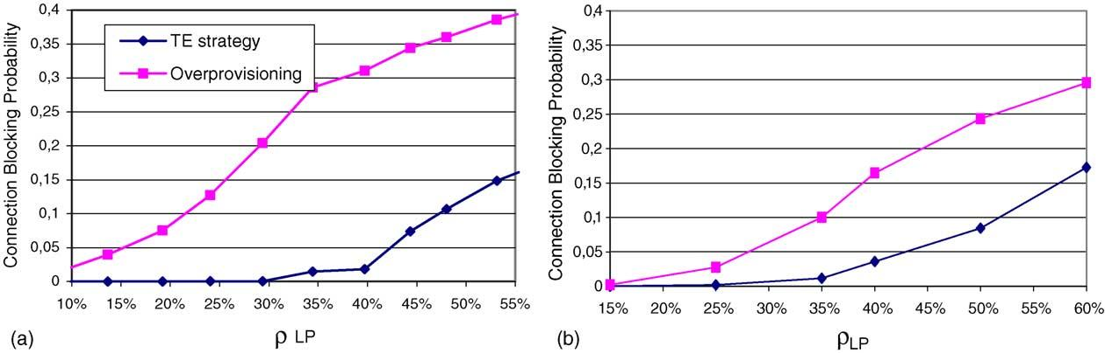

A. Bosco et al. / Performance Evaluation 59 (2005) 121–136

131

Fig. 4. TE strategy vs. overprovisioning in case of the simulation tool (a) and test bed (b) for different percentage of network
load due to LP trafﬁc.

5.2. Performance analysis result

The objective of the performance analysis is twofold: on one hand assess the good TE strategy oper-
ations and performance in comparison with conventional systems based on a classic “over-provisioned”
approach; on the other hand to demonstrate that the concrete realization of the control plane and its
implementation through a test bed allows good performance to be obtained.
For that reason the results reported here were obtained either by a simulation tool, aimed to evaluate
the system performance in terms of the blocking probability of required connection (usually named
connection blocking probability); or by means of measurements achieved utilizing the test bed.
Several simulations were run in order to analyze the performance of the TE system, in different
conditions. For the sake of brevity just a relevant case is reported here, equivalent to the network topology
corresponding to the test bed, described in Section 4. Speciﬁcally, Fig. 4a and 4b shows the comparison
between the proposed TE strategy and an over-provisioning system, in terms of connection blocking
probability with respect to the network load due to LP trafﬁc. In particular, Fig. 4a represents the results
obtained by means of the simulation tool while Fig. 4b shows the results achieved through measurements
on the test bed. It is assumed that HP trafﬁc occupies 50% of the network resources as maximum value
agreed by SLA. The connection blocking probability is deﬁned as the number of rejected connection
requests with respect to the total number of connection requests. It is worth noticing that both the simulation
and experimental results, even though not identical, lead to a common conclusion: the proposed TE
strategy leads to reduce the connection blocking probability of about 80% in case of average network
load of 40% due to LP (total network load is about 60%), and 100% in case of low network load. The
difference between the two ﬁgures essentially lays in the fact that the simulation cannot consider all the
aspects really affecting the performance as the test bed does.
In the following the analysis focuses two main aspects: (i) the good operations of the TE independently
of the implementation, and (ii) the good performance of the implementation solutions that have been
achieved.
The ﬁrst aspect basically depends on the way the hybrid routing works. In fact, thanks to the cooper-
ation between off- and on-line procedure, which aims at even distributing the trafﬁc in the network, the
congestion is reached for a value of total network load major of 75%. Practically, the provisioning tool,

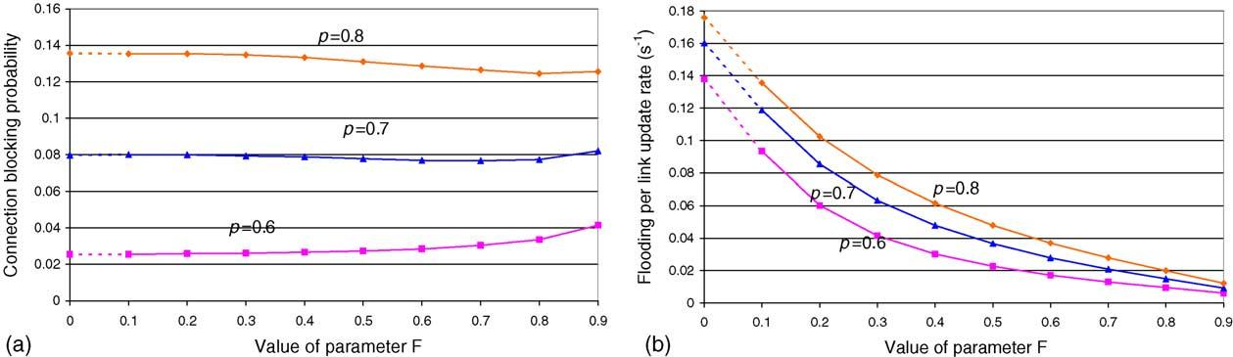

132

A. Bosco et al. / Performance Evaluation 59 (2005) 121–136

Fig. 5. CBR performance (a) vs. ﬂooding reduction (b) in presence of dynamic threshold mechanism.

that operates in the same way in the cases with and without signaling, aims at evenly distributing the HP
routes on the network in order to make available a consistent amount of bandwidth on each link for LP
trafﬁc [4], while the dynamic routing, as explained in [4], minimizes the network congestion favoring an
even distribution of the LP trafﬁc. Actually, potential congestions that would occur in given portions of
network are prevented.
As aforementioned, the test bed allows considering an important aspect that the simulation does not:
the impact of non-idealities relating to the signaling process on the performance of both on-line operations
(dynamic routing and pre-emption). Such non-idealities include the way the signaling ﬂood throughout the
network by means of real protocols is achieved, the real delays due to messages propagation throughout
the network, and the not instantaneous updating of the databases. Furthermore, the threshold mechanisms
previously introduced to signiﬁcantly limit the information ﬂooding, contribute to impact the performance.
In order to evaluate the robustness of the routing algorithm with respect to the threshold solution
implemented in the test bed that is described in Section 4, in Fig. 5, the performance of the dynamic
routing for different network loads is reported varying the factor F. Speciﬁcally, when F is 0.7 (Fig. 5a),
the connection blocking probability is substantially constant, while the ﬂooding reduction (Fig. 5b) is of
about 78% with respect to the situation without threshold.
The other function that has been analyzed is the pre-emption. As it has been mentioned in Section 2,
the algorithm that is used to perform the pre-emption aims to minimize the number of LSPs that are pre-
empted [2]. Moreover, the implementation of such mechanism, as described in Section 4, is performed
in order to meet the following requirements: HP modify is instantaneously, the LP pre-emption notify is
very fast and the re-routing of the LP pre-empted trafﬁc is performed with the dynamic routing algorithm
previously described, that minimizes the number of connections that are accommodated.
In order to better evaluate the amount of LP trafﬁc that is re-routed and the corresponding percentage
that is lost after re-routing, Fig. 6 shows the components of blocking probability of LP trafﬁc. Speciﬁcally
the component of LP blocking probability due to re-routing range from 0% (LP network load = 15%) to
25% (LP network load = 50%), with respect to the total blocking probability value.
The percentage of LP trafﬁc pre-empted has been evaluated for different HP loads (40, 50 and 60%)
as it is shown in Fig. 7. It is worth to highlight that in the worst case, when the maximum value of HP
trafﬁc represents 60%, and the average LP trafﬁc is 60% of the total network resources respectively, the
percentage of pre-empted LP-LSP, is about 10%.

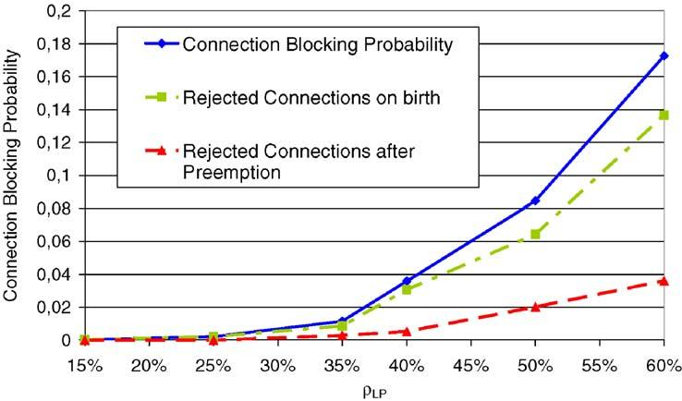
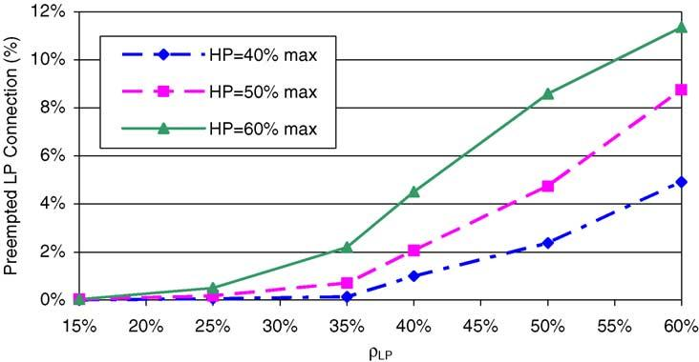

A. Bosco et al. / Performance Evaluation 59 (2005) 121–136

Fig. 6. Blocking probability components.

Fig. 7. Preempted LP connections.

133

Another important parameter to be analyzed is the time necessary to perform HP modify and LP
re-routing operations. As it is shown in the Table 1, the average time values for HP set-up and modify
coincide, and they are very similar to LP set-up time. This means that HP modify does not experiment delay
due to pre-emption and it is slightly dependent of network load. As far as the re-routing time for LP-LSP
is concerned, it ranges from 88 ms (60% of total network load) to 112 ms (85% of total network load).

Table 1
Averaged time for set up, re-routing, modify and percentage of preemption per minute
ρ_{TOT}(%)

Preemption per minute
T_{med}set-up LP (ms)
T_{med}re-routing LP (ms)
T_{med}set-up/modify HP (ms)
40
0.03
53.1
–
54.2
50
0.2
59.7
–
60.4
60
0.9
68
88.2
68.1
65
2.6
76.4
95.7
75.3
75
6
80.5
110
79
85
11.1
85.1
112
83.2

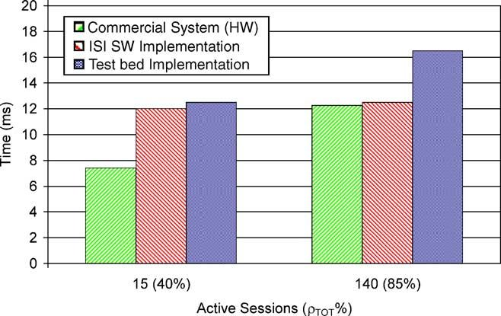

134

A. Bosco et al. / Performance Evaluation 59 (2005) 121–136

Fig. 8. RSVP propagation time comparison.

With the aim of giving an idea about the processing load for each node due to the pre-emption, the
number of pre-emption per minute is also considered (Table 1). Speciﬁcally for a network load of 40%,
the number of pre-emption per minute is 0.03, while in case of high network load (85%) it is equal to
11.1.
In order to evaluate the goodness of such results, in Fig. 8a, comparison between the measurements
collected in the test bed and those ones reported in literature regarding the propagation time for RSVP
messages, is performed. In case of 15 active sessions per node (40% of network load), the time measured
in the test bed and the value reported in literature is about 12 ms against 8 ms for commercial routers
[10], while in case of 140 active sessions per node the measurements performed by the test bed are about
16 ms, while for the other two cases are about 12 ms.

6. Conclusions

In this paper, the performance analysis of a trafﬁc engineering (TE) strategy for MPLS based network,
described in [1] is carried out. Speciﬁcally the implementation based on a distributed control plane
(Internet-like) has been investigated and realized by means of a test bed where real signalling protocol
(RSVP-TE) and routing protocols (OSPF-TE) have been implemented. Moreover, the extension of such
protocols has been performed in order to support the TE functions.
Speciﬁcally, the TE strategy is based on the combination of hybrid routing (off- and on-line methods)
and bandwidth engineering (BE) mechanism, that makes use of modify and re-routing functions. Two
classes of service are considered high priority (HP) class and low priority (LP) class. In order to preserve
the feasibility of the solution in real products, standard versions of routing (OSPF-TE) and signalling
(RSVP-TE) protocols have been implemented. Scalability issue has been also considered. In fact the
implementation of the TE strategy has been performed limiting the OSPF-TE ﬂooding by means of
a threshold based mechanism. This mechanism consists in a solution that controls OSPF-TE ﬂooding
dynamically in the bases of the occupancy of the link, in order to performs more ﬂooding only when the
link is very loaded. The robustness of the routing algorithm that is used for the on-line operations with
respect to this mechanism has been also analyzed.

A. Bosco et al. / Performance Evaluation 59 (2005) 121–136

135

Furthermore, a simulation tool, that is based on a centralized unit that performs routing decision in ideal
environment, has been used in order to evaluate the performance of the TE strategy without considering
the impact of the signaling proper of a distributed control.
The results obtained using either the simulation tool and the test bed, show that the TE strategy
allows to accommodate a superior amount of trafﬁc with respect to a traditional over provisioning where
bandwidth overbooking is performed, while providing different QoS. Speciﬁcally, in order to evaluate
the performance of the TE strategy the following considerations apply. Tight QoS for high priority (HP)
trafﬁc is provided, because HP-LSP are guaranteed up to a maximum bandwidth value agreed by SLA,
whatever is the network load. The HP trafﬁc uses just the bandwidth that it needs (minor of maximum
value) putting at disposal to LP trafﬁc the bandwidth that is not used temporarily, but HP-LSPs do not
suffer delay when it requires bandwidth increase if this portion of bandwidth is occupied by LP trafﬁc.
As far as the QoS for LP trafﬁc is concerned, good performances are also obtained, even if the
LP-LSP pre-emption algorithm, that minimizes the number of the LP-LSP to be pre-empted, uses just
local information of the LP-LSP, due to the fact that the implementation of the solution is distributed.
Speciﬁcally, the simulation results, obtained by means of the test bed, shown that the percentage of LP-
LSPs that are pre-empted is very slight (2% in case of 65% of average network load), and the amount of LP
trafﬁc that is torn down after pre-emption is small. In fact, the LP blocking probability due to re-routing
is a slight component of the total blocking probability (set-up and re-routing blocking probability). This
allows providing a QoS better that traditional best effort also for trafﬁc that is handled dynamically.
Moreover a “pre-emption notify” mechanism has been also implemented, in order to perform LP-LSP
re-routing quickly. Speciﬁcally the average time values for HP set-up and modify coincide, and they are
very similar to LP set-up time and are slightly dependent of network load. As far as the re-routing time
for LP-LSP is concerned, an interesting result is obtained (re-routing time ranges from 88 to 112 ms for
60 and 85% of the total network load, respectively). The processing load has been also estimated in terms
of number of pre-emption per minute that range between 0.03 and 11.1 for 40 and 85% of high trafﬁc
load. In order to better evaluate the measurement obtained by the test bed, a comparison between the
measurements collected in the test bed and those ones reported in literature regarding the propagation
time for RSVP messages, is also performed. The results shown similar results in case of 15 sessions per
node (12 ms versus 8 ms of commercial routers), while more difference has been veriﬁed in case of 140
sessions per node (16 for the test bed against 12 for the commercial routers).
The next step of this work will be introducing data plane in order to perform speciﬁc measurements
on the trafﬁc.

References

[1] P. Iovanna, R. Sabella, M. Settembre, Trafﬁc engineering strategy for multi-layer networks based on the GMPLS paradigm,
IEEE Netw. 17 (2) (2003) 28–37.
[2] A. Bosco, E. Manconi, R. Sabella, L. Valentini, An innovative solution for dynamic bandwidth engineering in MPLS
networks with QoS support, Photonic Netw. Commun. 7 (1) (2004) 37–42.
[3] M. Settembre, R. Sabella, G. Oriolo, F. Razza, F. Ferlito, G. Conte, A multi-layer solution for path provisioning in new
generation optical/MPLS networks, J. Lightwave Technol. 21 (5) (2003) 1141–1155.
[4] R. Sabella, P. Iovanna, G. Oriolo, P. D’Aprile, Strategy for dynamic routing and grooming of data ﬂows into lightpaths in
new generation networks based on the GMPLS paradigm, Photonic Netw. Commun. 7 (2) (2004) 131–144.
[5] D. Adwuche et al., SVP-TE: extensions to RSVP for LSP tunnels, IETF RFC 3209.

136

A. Bosco et al. / Performance Evaluation 59 (2005) 121–136

[6] A. Shaini, et al., Evaluating the overheads of source direct quality of service routing, in: Int. Conf. Netw. Protocols (ICNP),
1998.
[7] Zebra Home Page, http://www.zebra.org/.
[8] IBCN test lab Home Page http://dsmpls.atlantis.rug.ac.be/.
[9] L. Berger et al., Generalized multi-protocol label switching (GMPLS) signaling resource ReserVation protocol-trafﬁc
engineering (RSVP-TE) e, IETF RFC 3473, proposed standard.
[10] K. Nґemeth, G. Fehґer, I. Cselґenyi, Benchmarking of signaling based resource reservation in Internet, in: Networking, 2000.
[11] P. Aukia, M. Kodialam, P.V.N. Koppol, T.V. Lakshman, H. Sarin, B. Suter, RATES: a server for MPLS trafﬁc engineering,
IEEE Netw. 14 (2) (2000) 34–41.
[12] A. Elwalid, J. Ching, S. Low, I. Widjaja, MATE: MPLS adaptive trafﬁc engineering, in: Proceedings of IEEE INFOCOM’01,
Anchorage, USA, 2001.
[13] P. Trimintzios, L. Georgiadis, G. Pavlou, D. Grifﬁn, C.F. Cavalcanti, P. Georgatsos, C. Jacquenet, Engineering the multi-
service Internet: MPLS and IP-based techniques, in: Proceedings of IEEE International Conference on Telecommunications,
Bucharest, Romania, 2001.
[14] I.F. Akyildiz, T. Anjali, L. Chen, J.C. de Oliveira, C. Scoglio, A. Sciuto, J.A. Smith, G. Uhl, A new trafﬁc engineering
manager for DiffServ/MPLS networks: design and implementation on an IP QoS Testbed, Comput. Commun. 26 (2003)
388–403.
[15] Source forge MPLS home page, http://mpls-linux.sourceforge.net/.
[16] A. Botta, P. Iovanna, R. Mameli, G. Piantanida, S. Salsano, Extending MPLS trafﬁc engineering to deal with QoS, in: IEEE
Softcom 2003, 7–10 October 2003. Split, Dubrovnik (Croatia), Ancona, Venice (Italy).

